Assignment Description
1) Write a program which implements Fleury's algorithm

1 Readme Documentation
This program creates a graph and generate a Eulerian path/cycle using Fleury's Algorithm, if one exists

2 Flowchart Screen Shots

3 UML and Use Case Diagrams
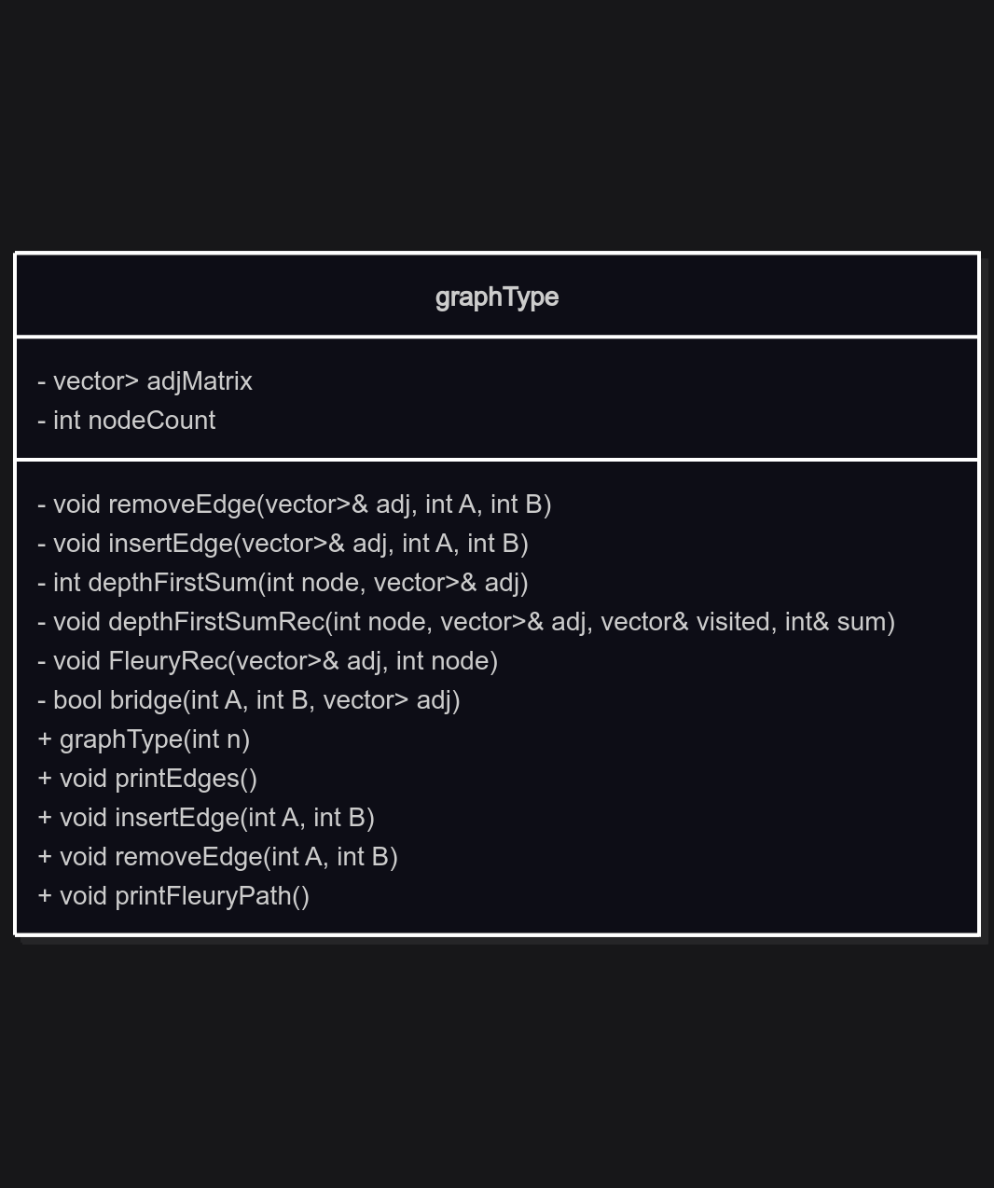

4 Source Code of All files (.h, .cpp)
#include <iostream>
#include <vector>
#include <algorithm>
#include <numeric>

/*
*Name: Spanning Graphs
*Author: Wesley Hixon
*Date Last Updated: 12/11/2025
*Purpose: Create a graph and generate a eulerian path/cycle using Fleury's Algorithm, if one exists
*/

class graphType{
private:
std::vector<std::vector<bool>> adjMatrix;

void removeEdge(std::vector<std::vector<bool>> &adj, int A, int B){
adj[A][B] = false;
adj[B][A] = false;
}

void insertEdge(std::vector<std::vector<bool>> &adj, int A, int B){
adj[A][B] = true;
adj[B][A] = true;
}

// Finds the number of nodes accessible from a root node
int depthFirstSum(int node, std::vector<std::vector<bool>> &adj){
std::vector<bool> visited(adj.size(), false);
int sum = 0;

for(int i = 0; i < adj.size(); i++){
if(adj[node][i]== true && visited[i] == false){
depthFirstSumRec(i, adj, visited, sum);
}
}
return sum;
}

void depthFirstSumRec(int node, std::vector<std::vector<bool>> &adj, std::vector<bool> &visited, int &sum){
visited[node] = true;
sum += 1;

for(int i = 0; i < adj[node].size(); i++){
if(adj[node][i] == true && visited[i] == false){
depthFirstSumRec(i, adj, visited, sum);
}
}
}

void FleuryRec(std::vector<std::vector<bool>> &adj, int node){
std::cout << node;

int adjacentCount = std::accumulate(adj[node].begin(), adj[node].end(), 0);

if(adjacentCount == 0){
return;
}
else if(adjacentCount == 1){
std::cout << "->";
for(int i = 0; i < adj.size(); i++){
if(adj[node][i] == true){
removeEdge(adj, node, i);
FleuryRec(adj, i);
break;
}
}
}
// If two or more adjacent, only navigate thru edges that aren't bridges
else{
std::cout << "->";
for(int i= 0; i < adj.size(); i++){
if(adj[node][i] == true && !bridge(node, i, adj)){
removeEdge(adj, node, i);
FleuryRec(adj, i);
break;
}
}
}
}

// Determines if the edge from A--B is a bridge
bool bridge(int A, int B, std::vector<std::vector<bool>> adj){
int beforeRemoval = depthFirstSum(A, adj);

removeEdge(adj, A, B);
int afterRemoval = depthFirstSum(A, adj);

if(beforeRemoval == afterRemoval){
return false;
}
else{
return true;
}
}

public:

graphType(int n){
adjMatrix = std::vector<std::vector<bool>>(n, std::vector<bool>(n, false));
}

void printEdges(){
for(std::vector<bool> a : adjMatrix){

for(bool value : a){
std::cout << value << " ";
}
std::cout << std::endl;
}
}

void insertEdge(int A, int B){
insertEdge(adjMatrix, A, B);
}

void removeEdge(int A, int B){
removeEdge(adjMatrix, A, B);
}

void printFleuryPath(){
auto adj = adjMatrix;

// Find the degrees of each node in the graph
std::vector<int> nodeDegrees(adj.size(), 0);
for(int i = 0; i < adj.size(); i++){
nodeDegrees[i] = std::accumulate(adj[i].begin(), adj[i].end(), 0);
}

// Find the number of odd degrees
int oddDegrees = 0;
for(int degree : nodeDegrees){
if(degree % 2 == 1){
oddDegrees++;
}
}

if(oddDegrees != 0 && oddDegrees != 2){
std::cout << "No Eulerian path or circuit";
return;
}

// If 0 odd degree nodes, start at node 0
if(oddDegrees == 0){
FleuryRec(adj, 0);
}
// If 2 odd degree nodes, find an odd degree node and start there
else{
for(int node = 0; node < nodeDegrees.size(); node++){
if(nodeDegrees[node] % 2 == 1){
FleuryRec(adj, node);
break;
}
}
}
}

};

int main(){

graphType g(5);

g.insertEdge(1, 2);
g.insertEdge(2, 0);
g.insertEdge(0, 1);
g.insertEdge(3, 1);
g.insertEdge(3, 4);

g.printEdges();

std::cout << std::endl;

g.printFleuryPath();

std::cout << std::endl;
return 0;
}

5 Three Use Case Screen Shots
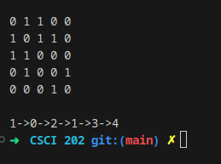
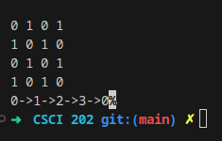
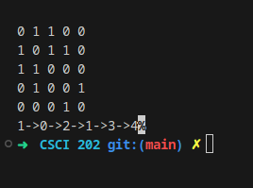

(Optional) GitHub URL

